**Practical No. 7**

1. **Working with REST API using express.**

**student.json**

{

"student1":{

"rollno":1,

"name":"Mahesh",

"address":"kudal"

},

"student2" : {

"rollno":2,

"name":"Dinesh",

"address":"Malvan"

},

"student3":{

"rollno":3,

"name":"Sanjay",

"address":"Sawantwadi"

}

}

1. **List all users from ‘student.json’ file**

**Code:**

var express = require('express');

var app = express();

var fs = require("fs");

app.get('/listUsers', function (req, res) {

fs.readFile( __dirname + "/" + "student.json", 'utf8', function (err, data) {

data=JSON.parse(data);

console.log(data);

res.send( data );

});

})

app.listen(3030);

console.log("Server started and listing on port 3030")

**Output:**

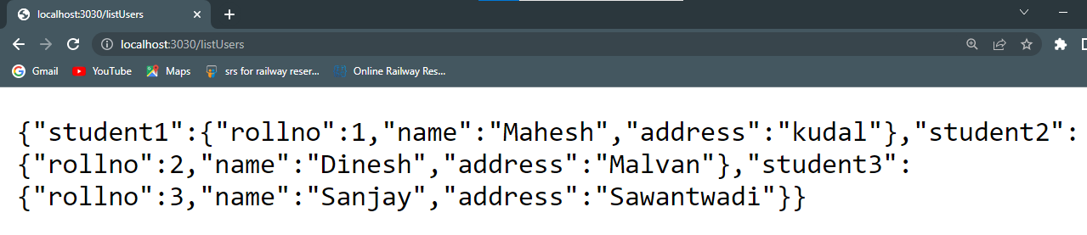

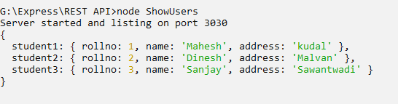

1. **Add User on Server**

**Code:**

**adduser.html**

<html>

<body>

<form action="http://localhost:3030/addUser" method="post">

<input type=submit value="ADD">

</form>

</body>

**AddUser.js**

var express = require('express');

var app = express();

var fs = require("fs");

var student={

"student4":{

"rollno":4,

"name":"Dhanjay",

"address":"Kankavli"

}

}

app.post('/addUser', function (req, res) {

// First read existing users.

fs.readFile( __dirname + "/" + "student.json", 'utf8', function (err, data) {

data = JSON.parse( data );

data["student4"] = student["student4"];

console.log( data );

});

})

app.listen(3030)

console.log("Server started....");

**Output:**



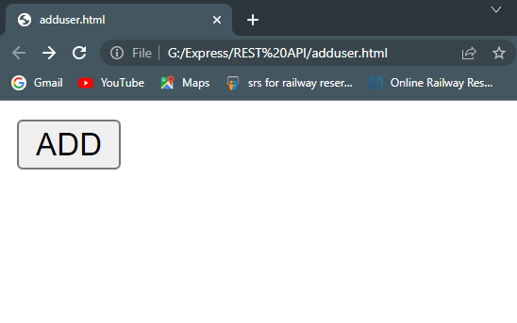

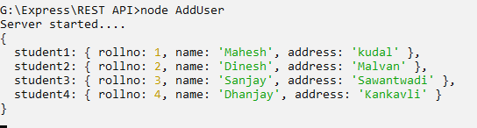

1. **Delete user from server**

**Code:**

var express = require('express');

var app = express();

var fs = require("fs");

var id = 2;

app.delete('/deleteUser', function (req, res) {

// First read existing users.

fs.readFile( __dirname + "/" + "student.json", 'utf8', function (err, data) {

data = JSON.parse( data );

delete data["student" + 2];

console.log( data );

});

})

app.listen(3030);

console.log("Server started....");

**Output:**





: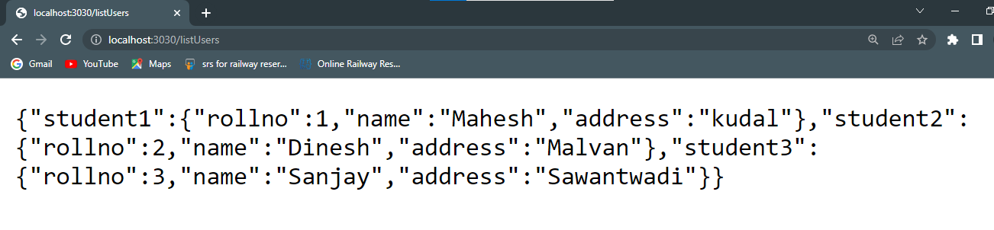

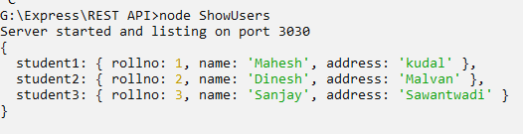

1. **Display Single record from ‘student.json’ file**

**Code:**

var express = require('express');

var app = express();

var fs = require("fs");

app.get('/:rollno', function (req, res) {

// First read existing users.

fs.readFile( __dirname + "/" + "student.json", 'utf8', function (err, data) {

var students = JSON.parse( data );

var student = students["student" + req.params.rollno]

console.log( student );

res.send(student);

});

})

app.listen(3030);

console.log("Server started...");

**Output:**



